Alamo Area Crime Prevention Association
CSI Registration, 3/07/2022 – 3/11/2022, $325.00 M-F, 9AM – 6PM
Crime Scene Investigation (40 Hours TCOLE # 2106)
Training Location: Saint Philip of Jesus, School Building
129 Bank Street, San Antonio, TX 78204
First Name: ___________________________ Last: _______________________________
PID Number: _______________ DOB: ______________________
Agency: _______________________________________________
Mail Address: __________________________________________
City: _______________________ State: _____ Zip: ___________
Work Phone: (____)______________ Cell Phone: (____)______________
PLEASE CHECK ALL THAT APPLY:
 Yes, I have a special needs request, Dietary / Accessibility, etc.
Please explain your needs: ______________________________________________
 My agency/company requires an invoice/billing before preparing a payment
 I am bringing a check or cash with me, $325.00
 I will be paying by credit/debit card when I arrive for the training
Credit processing fees: $12.26 - Total charged: $337.26

Mail Registration form to: AACPA, 10317 Vigilante Trail, Converse TX 78109
Make check payable to: AACPA, (Alamo Area Crime Prevention Association) ($325.00 if mailed)
AACPA & TCPA are non-profit 501c3 organizations.
IRS Form “W-9” is available at: https://www.aacpa.net/w9/w9.pdf
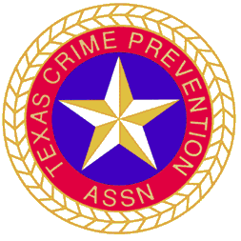
SPECIAL INSTRUCTIONS: Student should bring a laptop; the course material will be provided for download at the beginning of the training class.
Contact Information: TCOLE Instructors: Juan Contreras 210-388-2772
Gilbert De La Portilla 210-722-0523 (text ok)
Registration Help: Don Carr 210-381-0250 (text ok)

